Deep Learning Approaches for Fake News Detection

Zhangbo Cheng  
Penn State College of Engineering *Penn State University*University Park, PA 16801, United States  
zfc5091@psu.edu

*Abstract*—Technology has dominated our lives for the past few decades. It has changed the way we communicate and share information. Information sharing is no longer limited by physical boundaries. It is easy to share information globally in the form of text, audio and video.

One credit Part of this ability is social media platforms. These platforms facilitate the sharing of personal views and information with a wider audience. They have taken over traditional media platforms due to the speed and concentration of content. However, it has become just as easy for people with malicious intent with the intention of spreading fake news on social media platforms. Social media for news consumption is a double-edged sword. On the one hand, its low cost, ease of access and the speed with which information is disseminated lead people to seek and consume news from social media. On the other hand, it allows for the widespread dissemination of "fake news," i.e., low-quality news with intentionally false information.

The widespread dissemination of fake news has the potential to have extremely negative effects on individuals and society. Therefore, the detection of fake news on social media has recently become an emerging research of great interest. Fake news detection on social media presents unique features and challenges that make existing detection algorithms from traditional news media ineffective or inapplicable.

Keywords—Fake news detection · natural language processing · BERT · Deep Learning long short term memory, transformers, language model pre-training

# Introduction

It is well known that social media platforms like Facebook, Twitter and Instagram have enabled massive connectivity and communication. It has revolutionized the speed at which information is shared in people's lives and increased its reach. However, these platforms have also led to an increase in the creation and spread of fake news. Fake news has not only influenced people in the wrong direction, but it has also taken human lives. [1]Especially in this critical period of the Covid19 pandemic, it is easy to mislead people into believing deadly information. [2]Therefore, it is important to curb fake news at its source and prevent it from spreading elsewhere. Therefore, it is important to curb fake news at the source and prevent its spread to a wider audience. First, we investigated techniques to automatically detect fake news from a data mining perspective. Different supervised text classification algorithms were evaluated by evaluating different supervised text classification algorithms on the fake news detection dataset. [3]And these classification algorithms are based on convolutional neural networks (CNN), long and short term memory (LSTM) and representatives of bidirectional encoder transformers (BERT). The importance of unsupervised learning in the form of pre-training of language models was also evaluated. and distributed word representations using a label-free corpus of covid tweets. The best accuracy of 98.41% was reported on the Covid-19 fake news detection dataset. detection dataset. But the proliferation of fake news poses a threat to individuals and society through the deliberate dissemination of misinformed news.

For the past few decades, technology has dominated our lives. It has altered the manner in which we communicate and share information. Physical barriers to information sharing are no longer an issue. It is simple to communicate information in the form of text, audio, and video around the world. Social media platforms are an important aspect of this capability. These platforms make it easier for people to share their personal opinions and knowledge with a larger audience. Because of the speed and focus of content, they have surpassed traditional media outlets. Malicious persons, on the other hand, can easily distribute bogus news on social media platforms. Fake news is defined as provable incorrect information that is shared with the goal of deceiving readers [1]. It's been utilized to make political and social change.

People's minds are skewed by economic bias for personal advantage. Its goal is to manipulate and exploit individuals by providing fake content that appears to be authentic. Fake news has also resulted in mob lynchings and rioting in extreme circumstances [2]. As a result, it's critical to put a halt to the dissemination of incorrect information on the internet. Controlling fake news is especially important in light of the current Covid-19 situation. Pandemics make it simple to exploit mentally ill people who are eagerly awaiting the end of this phase. Due to disinformation about covid in social media and even mainstream media, several people have reportedly committed suicide after being diagnosed with the disease. Promoting deceptive techniques exacerbates the problem. Researchers have been working on detecting fake news for a long time.

Although manual detection is the most reliable method, it has speed limits. The huge amount of content created on the Internet makes human verification impossible. As a result, automatic false news detection is becoming increasingly vital.[8] The authenticity of social media material has been investigated using machine learning algorithms. These algorithms are primarily based on the news' content. Another set of key indications is user characteristics, social networks, and the polarity of their content. It's also usual to examine user behavior on social media networks and assign them reliability rankings. Fake news peddlers may not behave normally when it comes to sharing, and they may also spread more extreme stuff.

All of these characteristics combined provide a more accurate estimation of genuineness. We focus on the detection of bogus news connected with covid in this paper. [7]The paper describes a system that was tested against the Contraint@AAAI 2021 Covid19 Fake News Detection Shared Task in the Contraint@AAAI 2021 Covid19 Fake News Detection Shared Task . The goal of the project is to enhance the classification of news as fake or true using Covid-19. Data from numerous social media sources is used to construct the shared dataset (e.g. Instagram, Facebook, Twitter, etc.). The task of detecting bogus news is written as a text classification problem. We rely solely on the news' content, ignoring other essential features such as user characteristics, social circles, and so on, which may not always be available. Recent breakthroughs in deep learning-based text classification are discussed.

For fake news detection tasks, we assess recent developments in deep learning-based text categorization algorithms. Pre-trained models based on BERT, as well as original models based on CNN and LSTM, are among these strategies. Using a monolingual corpus coupled with covid, we additionally assess the efficiency of pre-training language models and training word embeddings. In essence, we rely on these models to detect differentiating linguistic, stylistic, and polarity traits in news pieces that aid in determining legitimacy.

Despite the availability of various fact-checking sites, such as PolitiFact, robust detection technology is needed to combat the increase in fake news. to counter the increase in fake news. The above mentioned evaluation of those different supervised text classification algorithms on the fake news detection dataset Different supervised text classification algorithms show promising results in terms of fake news classification, [6]however. Their black-box nature makes it difficult to explain their classification decisions and to guarantee the quality of the models. We address this problem here by proposing a new interpretable framework for fake news detection. We address this problem here by proposing a novel interpretable fake news detection framework based on the recently introduced Tsetlin Machine(TM). Briefly, we utilize the concatenated sentences of Tsetlin Machine TM to capture lexical and semantic properties of real and fake news texts. In addition, we use sentence combinations to compute the plausibility of fake news. [4]For evaluation, we conduct experiments on two publicly available datasets, PolitiFact and GossipCop, and demonstrate that the TM framework significantly outperforms the previously published In terms of accuracy, the TM framework significantly outperforms the previously published baseline by at least 5%. Also, we provide a logic-based interpretable representation. In addition, our method provides higher F1 scores than BERT and XLNet; however, we obtain slightly lower accuracy rates. Finally, we present an interpretability on our case study model, showing how it decomposes into meaningful words and their negation.

The Internet's social media platforms have become a vital part of daily life, and an increasing number of individuals are getting their news from social media rather than traditional media such as newspapers. Cost effectiveness, freedom of remark, and shareability among friends are all important factors. Despite these benefits, social media exposes users to a lot of false information. Fake news stories are especially dangerous because they try to fool people for political and commercial gain. In recent years, we've seen the development of false news in social media, including news blogs, Twitter, and other social media platforms. The majority of online misinformation is being written by hand. Natural language models like GPT-3, on the other hand, can generate plausible fake news automatically, potentially accelerating future growth.

This expansion is worrisome because the majority of people now consume news through social media and news blogs. Fake news, in fact, poses a severe threat to journalism, individuals, and society. It has the capacity to destabilize societal belief systems while also encouraging bias and false hope. Fake news about religious or gender inequalities, for example, might cause detrimental bias. Fake news has the potential to incite violence or conflict. When people are exposed to fake news on a frequent basis, they develop a distrust for actual news, affecting their capacity to discriminate between fact and fiction. It is vital to create technologies that can automatically expose bogus news in order to mitigate these detrimental consequences. Fake news identification raises a slew of difficult research issues.

Fake news is created with the intent of deceiving the recipient. As a result, detecting fake news based on linguistic content, style, and diversity is challenging. Fake news, for example, may use real-life events and context to back up bogus claims. For effective detection, we need to employ a knowledge base of linguistic patterns in addition to hand-crafted and data-specific features. The use of crowdsourcing data to train fake news classifiers could make them inappropriate for future news events. Fake news emerges on a regular basis, quickly obliterating prior textual content. As a result, some research, for example, use attention to reveal more durable semantic patterns by combining social context and hierarchical neural networks.

Despite substantial advancements in deep learning-based fake news detection tools, there are few approaches to describe how they classify information. There is currently a dearth of understanding of the factors that underpin fake news. As a result, describing why certain news pieces are considered phony could lead to fresh insights. Transparency in decision-making could also aid in identifying and correcting model flaws. Previous research, to our knowledge, has not yet addressed the interpretability of fake news identification.

Fake news detection is a very prominent and important task in the field of journalism, not only in news related to covid19. This challenging problem is seen as critical in the political domain, but it is even more challenging when it comes to identifying fake news on a multi-domain platform. Thus it can be even more challenging when identified on a multi-domain platform. In this paper, we present two more effective models based on deep learning Effective models for learning are used to solve the problem of detecting fake news in multi-domain online news content. We evaluate our technique on two recently released datasets. The two recently released datasets, FakeNews AMT and Celebrity, for fake news detection. [5]The proposed systems yielded encouraging performance, outperforming current state-of-the-art systems based on manual feature engineering by a significant margin of 3.08% and 9.3%. and 9.3%. In order to exploit the dataset available for the task of interest, we performed cross-modeling. To leverage datasets available for related tasks, we performed cross-sectional analysis, i.e., models trained on FakeNews AMT and models tested on Celebrity and vice versa. tests and vice versa to explore the applicability of our system in different domains.

Data is created on a regular basis thanks to the emergence of social media and news media. The amount of data created in this way is tremendous, and it frequently contains incorrect information. As a result, it is vital to verify its legitimacy. People nowadays rely on social media and a variety of other online news streams as their sole source of information. According to a survey conducted by the Consumer News and Business Channel (CNBC), more individuals absorb news through social media than through newspapers1. As a result, in order to give real news to such consumers, the news industry must first verify the legitimacy of such online news content.

Even humans cannot (easily) understand the validity of news stories after reading them, making this task extremely challenging for machines. Previous attempts to detect fake news relied solely on datasets from satirical news content sources, such as fact-checking sites like The Onion, Politi-Fact, and Snopes, as well as information from viral news sites like BuzzFeed. However, these sources are not without limitations and challenges. With a blend of irony and absurdity, satirical news mocks current events. Much of the work in the field of false news detection fits into this category, and it is restricted to a single area (i.e., politics). The issue may become more difficult and general if we look at this false news identification challenge in many domain scenarios. We are working to solve the problem of recognizing fake news across multiple domains. This endeavor is more difficult than when news is solely collected from a single domain (i.e., a single-domain platform). We use a dataset that includes news content from many websites. The aim is to classify whether the given news is a real internet item from several domains, given a news topic and the accompanying news body documents.

They provide a starting point. The model is built on manual language characteristics and a support vector machine (SVM). In the FakeNews AMT and Celebrity news datasets, the SVM-based model obtains 74 percent and 76 percent accuracy, respectively. This is a classification difficulty, according to us. As a result, the suggested prediction model is a binary classification system that classifies fake and confirmed content from several domains of online news. We use two deep learning algorithms to solve the multi-domain false news detection challenge. Model 1 is a deep neural network model based on bi-directional gated recurrent units (BiGRU), whereas Model 2 is based on the embedded language model (ELMo). It's worth noting that this is the first time deep learning has been used to address a problem in this setting. Such issues have not yet been addressed by the approach, particularly the word attention mechanism. The majority of the existing work on this subject employs solutions that rely on handcrafted elements. The suggested solution uses an end-to-end deep neural network architecture rather than hand-crafted feature engineering or a sophisticated NLP pipeline. Both concepts outperform current-generation systems.

# Literature Review

Detecting fake news through traditional news and article channels is entirely dependent on the reader's familiarity with the subject and content of the piece. However, there are a variety of indicators that may be used to identify bogus news transmitted via social media. One indication might be to determine a user's authenticity by studying their followers, the quantity of followers, their activity, and their registration information. Along with these information, additional criteria such as extra URLs, social media post dispersion characteristics, and content-based mixture models are utilized to determine if news is phony or authentic. Another research used the structural qualities of social networks to define "diffusion networks," which refer to the spread of a certain subject. Together with other social network characteristics, these diffusion networks aid in classifying rumors in social media using classifiers such as SVM, random forests, or decision trees. Apart from utilizing elements that allow for the sharing of user patterns and personal information associated with false news, another setting for identifying any social media news article is the comment area. A linguistic research revealed terms such as "Is it true?" and "Is this true?" Within the comments area of a few fictitious postings. Additionally, they created a system that classifies rumors by clustering such query strings in addition to basic terms. Consider an alternate strategy that takes into account the ternary link between publishers, news pieces, and false news users. TriFN, a tri-relational embedding framework for identifying false news items on social media, was created using this connection. Four types of embeddings were created, namely news content embeddings, user embeddings, user-news interaction embeddings, and publisher-news relationship embeddings, all of which contribute to the spread of false news, and TriFN was used to identify fake news using a semi-supervised classifier. The propagation knowledge associated with false news pieces, such as their path development and transformation, may also be utilized to detect bogus news initially. Additionally, altered routes were represented as vectors for classification utilizing deep neural network architectures, namely RNNs for global variation and CNNs for local variation. Along with user and social environment characteristics, the substance of false news is a well-established strategy for detecting fake news and rumors. A recent technique further classifies news by utilizing explicit and latent aspects of textual content. To identify bogus news stories, basic deep convolutional neural networks are also employed to extract contextual information characteristics from them.

Detecting spoofing is not a novel challenge in natural language processing. Detection of bogus internet marketing, false customer reviews, and spam are all critical application areas. The identification of fake news focuses on the dissemination of deceptive news pieces. Typical detection strategies make use of linguistic information extracted from text or visual features. In general, approaches for detecting fake news fall into two categories: knowledge-based models that use external sources to fact-check news stories, and style-based models that employ linguistic elements to capture writing style. Numerous research, including those that use publicly available data, serve as the foundation for in-depth examination of false news and detection approaches. Recent advances in the accuracy of false news categorization have been made possible by deep learning-based latent representations of text. However, latent representations are sometimes difficult to analyze and give only a cursory understanding of how false news works. It introduces social context-based characteristics derived from user profiles and activity patterns. Other techniques to supervised learning depend on social platform-specific characteristics such as likes, tweets, and retweets. While tremendous progress has been made in detecting bogus news, interpretability has received less attention. Typically, existing deep learning approaches take characteristics for the purpose of training classifiers without providing an interpretable explanation. This lack of transparency in terms of comprehension renders them opaque. We present a unique TM-based technique for detecting bogus news in this research. TM is a relatively new pattern categorization, regression, and novelty detection technique that aims to close the interpretability and accuracy gaps in current state-of-the-art machine learning. We intend to increase the efficacy of fake news identification by utilizing TM's AND rules to capture the lexical and semantic aspects of false news. More crucially, our methodology is interpretable by design, both generally at the model level and locally for each false news prediction.

The literature on false news identification contains a considerable number of publications. Nowadays, the identification of false news is a major research topic that has increased academic attention. We can identify false news on two levels: conceptual and operational. Rubin conceptualizes three distinct categories of false news: i. outright fabrication ii. urban legends; and iii. satire. Conroy's study emphasizes language and fact-checking ways to determining the difference between true and misleading news on a conceptual level. Chen defines fact-checking as the process of verifying assumptions in news items in order to ascertain the reality of statements. Thorne provides a novel dataset for truth checking and validation using a big Wikipedia corpus as the evidence. Ferreira and Vlachos both have important works that employ text as proof. Fake News Challenge 2 hosted a competition to investigate how to develop artificial intelligence solutions for combating fake news. There were over 50 contestants who submitted their systems. Keselowski conducts a retrospective examination of the three top Fake News Challenge participants. Shaikh et al. identified bogus news by gesture recognition and connected the challenge of gesture classification to textual entailment. They handle this challenge using statistical machine learning and deep learning methods, respectively. The system produces cutting-edge outcomes. Another noteworthy piece of work in this field is the validation of human-generated assertions against the entirety of Wikipedia. Thorne's suggested dataset, fact extraction and validation, is aimed towards accomplishing this goal. Yin and Ross both produced noteworthy pieces in this vein.

Recent years have seen a surge in research towards the detection of false news. However, the majority of research in this topic has concentrated on the analysis and identification of hoax ideas via their primary avenue of distribution: social media. The preceding example was constructed using standard machine learning techniques (classification trees, SVM, etc.) and its unique characteristics (e.g. likes, follows, shares, etc.) in order to determine the chance of being incorrect for a certain post. The best results were obtained using this approximation, with clickbait news being spotted with a 93 percent accuracy. Other work, for instance, use graph-based approximations to investigate the link between people who share news and the path taken by the shared material in order to prohibit it and limit its possible spoofing impact. While the main tendency is to examine how hoaxes propagate, different approaches focusing on news content analysis have begun to develop. Along with sharing news's user attributes, language is utilized to differentiate bogus news. On the other side, assertions in articles are analyzed to identify information that contains erroneous facts. In terms of the utilization of contemporary deep learning algorithms, Fabula.ai, a startup recently bought by Twitter, employs a system that takes into account both news content and characteristics collected from social networks, achieving an AUC of 0.93. When different algorithms (classical learning and deep learning) are compared, categorizing news into true and false categories reaches a 95 percent accuracy rate. Finally, utilizing simply the news's content, a strategy based on convolutional neural networks is developed for detecting false news using headlines and headline pictures with a 92 percent accuracy.

1. Implementation

The dataset that was utilized in this study contains 44,898 news stories that have been classified as fake or true. It was gathered from two different sources. The fake ones are from the dataset Getting Actual About Fake News, whilst the real ones originate from credible sites like The New York Times or The Washington Post. The dataset comprises several characteristics for each article, such as title, text, topic, date, and so on. However, just the title and text were utilized in this project. This dataset was selected based on the assumption that it has been used in prior research with satisfactory results, therefore the quality of the news data may be presumed to be suitable for training a neural network-based model like the one suggested in this paper. The fake news corpus was utilized to test and fine-tune the model in addition to the dataset mentioned above. This corpus is made up of millions of internet articles that have been identified as bias, clickbait, fake, political, or genuine, and then combined to provide the same labels as the TI-CNN dataset. Tags including title, text, topic, and date are included in the false news detection dataset. The tags indicate if the tweets are bogus or genuine. On the other side, a total of 44,898 media articles and postings were gathered from various platforms, bringing the total to 44,898. Fact-checking websites like Politifact, NewsChecker, and Boomlive , as well as tools like Google Fact Check Explorer and the IFCN chatbot provided the training data with 23,481 false samples and 21,417 correct samples.

A. Transformation of data

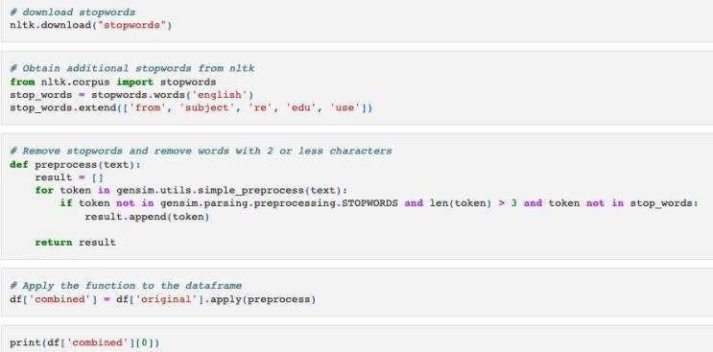

(1) Stop words:

Because this dataset has previously been well-curated, cleaning the data is an easy task. Stop words were eliminated in order to utilize it in this project. Stop words in English are words like "a," "an," "the," "of," "is," and others that often appear in phrases but add nothing to the overall meaning of the statement. It is preferable to delete these stop words and allow the model to concentrate on the words that reflect the sentence's core substance in order to reduce processing time. Some terms occur in the majority, if not all, of the papers. These less informative terms are more or less useful for retrieval outcomes, and will almost likely be useful for processing short texts using machine learning. However, in this situation, we must erase them. By deleting stop words, the recall rate may be enhanced by several percentage points or more. The inclusion of deactivated words not only raises the search's computational difficulty to that of an exhaustive search, but it also raises the search's spatial complexity out of control. There are 44,898 news items covered in this project, and the stop word vocabulary has roughly 700 stop words, so the chances of stop words appearing beneath each article are greater, and the inverted index may contain a big number of worthless words, using at least a hundred megabytes. As a result, if no processing is done, the storage space used will be much more.

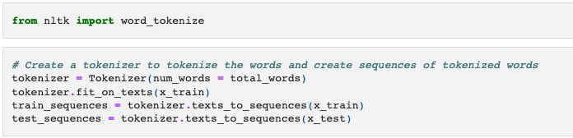

(2) Tokenizer:

To put it simply, a tokenizer is a function that divides sentences into words. keras.preprocessing.text. Tokenizer tokenizes (splits) text into tokens (words), keeping only the most frequently occurring terms in the corpus. Only the pre-specified words are kept in the num words option. Only the pre-specified number of words in the text are retained by the num words option. This is useful since the model should not produce a lot of noise by evaluating terms that are infrequently used. The majority of the words left with the num words option in real-world data are frequently misspelled. By default, the tokenizer filters out certain unnecessary tokens and lowercases the content. The tokenizer also stores a word index, a dictionary of words that may be used to give unique numbers to words, once it has been fitted to the data, which can be accessed through tokenizer.word index. Typically, the model anticipates that each sequence (training example) will have the same length (number of words/tokens). The maxlen option may be used to adjust it. A list of numbers has now been added to the training data. The length of each list is the same. There's also word index, which is a dictionary of the text corpus's most common terms. As previously stated, the enrichment will be interpreted using the GLoVE Word2Vec embedding. The Wikipedia corpus is used to train the GLoVE pre-training vector. This implies that certain words in the data may not show up in the embeddings. First, load the Glove Embeddings. The location to the folder where these GLoVE vectors will be downloaded must be specified. This glove embedding index is essentially a dictionary with words as keys and word vectors as values, with a dictionary length of around 1 billion for a np.array of length 300. Because just word index embeddings are required, a matrix containing only the necessary embeddings will be constructed. Taking use of GLoVE's preprocessing The designer did not change the words to lowercase while preparing for glove. This implies it has many variations of terms like "USA," "USA," and "USA." It also implies that although a term such as "Word" exists, there is no lowercase equivalent, i.e. "word." Explain how to improve coverage by using embedded knowledge. Adding more information to the embedding utilizing domain expertise and natural language processing (NLP) abilities may sometimes offer value, depending on the circumstance. For example, by adding polarity and subjectivity of words to the TextBlob module in Python, one may contribute external information to the embedding itself. TextBlob may be used to determine the polarity and subjectivity of any word. As a result, add this extra information to the embedding. A key component in improving the deep learning model's performance in the future. This section of the code is often reviewed numerous times throughout the project phase in order to enhance the model. To increase the coverage of word index and to integrate more functionality in the embedding, a lot of creativity may be demonstrated here. As a result, phrase-specific properties, such as sentence length, number of unique words, and so on, may be added as another input layer to supply more information to the deep neural network using the text preprocessing technique for embedding matrices.

(3)Data visualization

Matplotlib is a powerful toolkit for plotting and data visualization in Python. Data visualization is also one of the most important tasks of data analysis in this project, which can help researchers to do many operations, such as finding out the number of news under each different category, some data transformation necessary, etc. The end result of completing the data analysis might be to make an interactive data visualization.

These following codes is used to show the fake news from different area, the number 0 or 1 is means it is true or not.

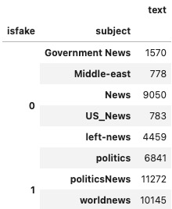

This part of codes is to plot the counts of words in different subjects, which make it more clearly.

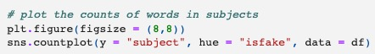

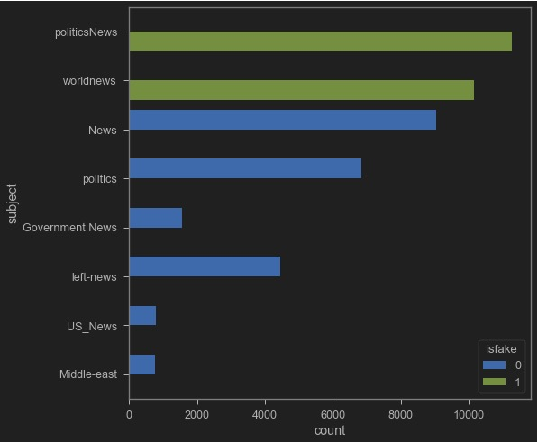

This following code is plotting the word cloud for text that is real.



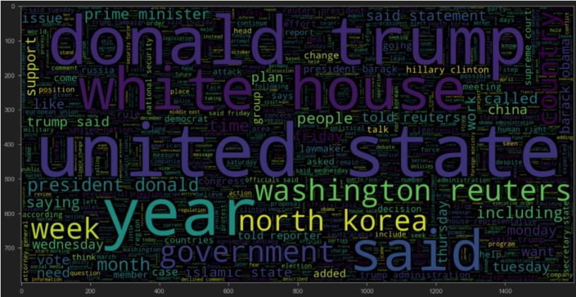

This following code is plotting the word cloud for text that is fake.



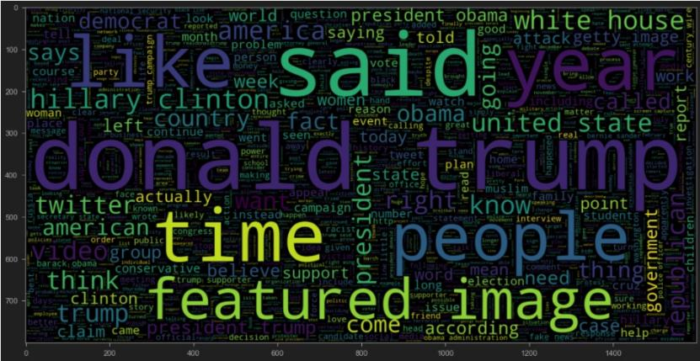

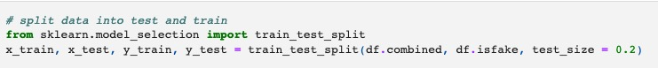

(4)Sets for training, validation, and testing

In general, the sample is separated into three distinct subsets: training, validation, and test. The training set is used to estimate the model, the validation set is used to establish the network structure or parameters that regulate the model's complexity, and the test set is used to evaluate the final optimized model's performance. The training set typically amounts for 50% of the entire sample, while the remaining 25% is randomly picked from the sample. When the sample size is tiny, the preceding partitioning becomes inapplicable. It is customary to reserve a limited sample size for the test set. The remaining N samples are then subjected to the K-fold cross-validation procedure. It is to split the sample into K equal parts, choose K-1 for training and the remaining one for validation, compute the sum of squared prediction errors, and finally average the sum of squared prediction errors of K times to get the ideal model structure. K, in particular, requires N, which is the way of leaving one out. The training set is used to train the model or to determine model parameters, such as the weights in an ANN; the validation set is used to perform model selection, i.e., to perform final optimization and determination of the model, such as the structure of an ANN; and the test set is used solely to test the trained model's generalization ability. Naturally, the test set does not ensure that the model is right; it only indicates that identical data with this model would provide similar results. However, in fact, the dataset is often separated into two groups, namely the training set and the test set, and the validation set is typically left out of most papers.

The Train-related data. This is the segment of data used to fit the model. This is the data set for which we already know the input and output values in order to train the machine to learn and identify the model's initial parameters through fitting. In Neural Networks, for example, we utilize the training data set and backpropagation to determine the best weights for each neuron.

The ratio of the two elements of this project is around 8:2. Multiple models will be trained in this project, and validation data will be entered into various models to compare their performance. The data will be fed into several models for comparative purposes. This is accomplished by enabling machine learning to modify the model parameters appropriately while the researchers are already familiar with the input and output datasets. Validation) is the process of subdividing the training data set into several validation data sets in order to train the model.

Test results. The primary distinction between the first two is that although both train and validation data are for the same object, testing data must be cross-object to ensure the model's stability. After deriving the optimum model from the training and validation sets, the test set is used to forecast the model. This is used to assess the best model's performance and classification capabilities. When a model is employed in practice, the discriminative impact of the test set is often utilized to measure the model's generalization capacity. Users evaluate a model's performance using the model performance dataset to determine the model's accuracy based on the error, which is often the difference between the expected and actual output.

The Validation Set is used to fine-tune the model parameters in order to find the best model. Due to the fact that the model already knows the input and output, the error determined from the Validation Set will be biased. Only the Test Set is utilized to assess the model's performance; the optimum model is not tuned. The ratio of training/validation/test is 50/25/25 in typical machine learning, although there are occasions when the model does not need much tweaking as long as it is fitted, or when the training itself is training+validation, like in cross validation. In certain circumstances, if the model does not need extensive adjustment or if the training itself is a combination of training and validation, such as cross validation, training/test = 8/2, as was the case in this project. However, since deep learning requires a huge quantity of data and neural network training requires a large number of data, you may allocate more data to training and minimize validation and test proportionately.

1. Novelty

The parent paper provides the basic Deep Learning model to detect the fake news. This following code is from the parent paper.

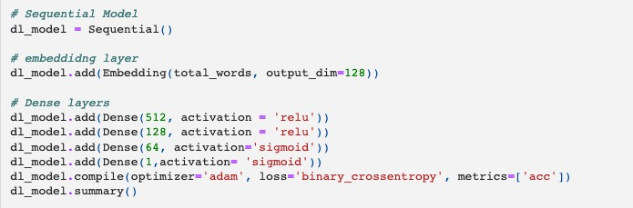



The outcome of original Deep Learning model

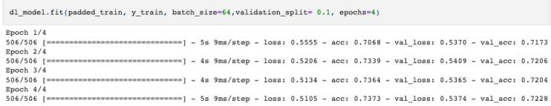

By increasing the efficient of detecting the fake news, this project changed the original Deep Learning model to the Bidirectional Long Short Term Memory Model. This following code is shown the changed made.

A. Bidirectional LSTM

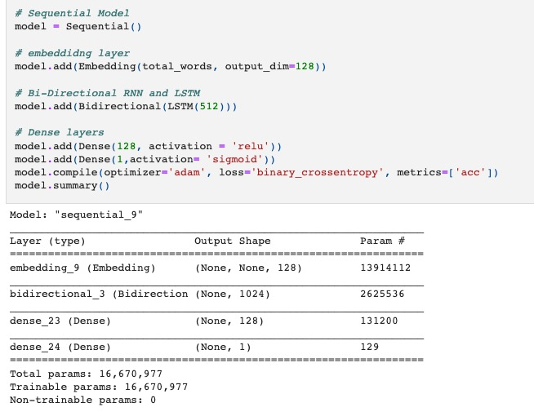

Bidirectional LSTMs are concerned with obtaining the maximum input sequence in both forward and reverse directions via input and output time steps. In practice, the architecture entails copying the first recurrent layer in the network to create two side-by-side layers, feeding the first layer with the input sequence and the second layer with a reverse copy of the input sequence. This approach is a general method for optimizing the performance of recently developed recurrent neural networks (RNNs).

To overcome the shortcomings of conventional RNNs. The purpose of this project is to propose a bidirectional recurrent neural network (BRNN) that can be trained using all available input data from a specific time period in the past and future. This approach involves dividing a standard RNN state neuron into two parts, one for positive temporal direction (forward state) and another for negative temporal direction (backward state).

Additionally, this technique has been applied to LSTM recurrent neural networks. The forward and reverse provision of the entire sequence is predicated on the availability of the entire sequence. This is typically a requirement when vectorized inputs are used in this practice. However, where the ideal time step is provided sequentially and in time, it may raise philosophical concerns. It is reasonable to provide input sequences in both directions in the field of speech recognition because there is evidence that humans interpret what they say using the entire context of discourse rather than a linear interpretation.

While bidirectional LSTMs were developed for speech recognition, their use in sequence prediction is critical, and LSTMs are a way to improve model performance.

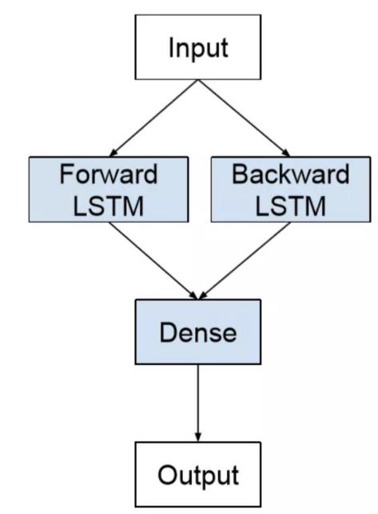

Bidirectional LSTM Model Accuracy : 0.9984409799554566

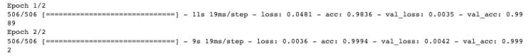

Besides the Bidirectional LSTM, This project also used the FLAML to do the detecting the fake news. The FLAML model also includes the XGBoost, LGBM and Random Forest in the mechanism. During the processing, the FLAML model will keep comparing the accuracy of the included model until find the best fit one.

B. FLAML

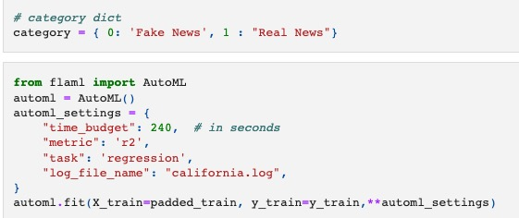

AutoML has achieved significant success in a variety of machine learning and Kaggle competitions over the last few years. AutoML frameworks are numerous; however, unlike some of the current SOTA automl frameworks, FLAML focuses on being lightweight while also taking hyper-parameters, learner characteristics and sample size into consideration. Additionally, the cost includes the time required for cross-validation or hold-out, in addition to the CPU time required for each trial. Consequently, the core of FLAML is in the way it accelerates and lightens the complex search interval, which is its primary function. FLAML, also known as A Fast and Lightweight AutoML Library, is a new automated machine learning framework promoted by Microsoft that is both efficient and light-weight in its design. AutoML is an abbreviation for automated machine learning, and we'll start with an example of hyperparameter optimization, which is one of the most commonly automated tasks in machine learning. In the case of manual hyperparameter tuning, for example, we frequently employ the following methodology:

Set the learning rate parameter of the model to 0.01, train the model, and obtain a score for an evaluation metric, such as an accuracy rate of 0.7, by evaluating the model.

Set the model learning rate to 0.1, train the model, and obtain the evaluation metric once more. For example, set the model learning rate to 0.65 and obtain the evaluation metric once more.On the basis of the foregoing observations, we might try a value less than 0.01, and so on.When we solved this parameter optimization problem manually, it is easy to see that we unintentionally introduced some optimization methods into the process without realizing it. The accuracy decreases as the learning rate parameter is increased, so we continue to experiment by adjusting the learning rate parameter in the opposite direction. This is based on the fact that "accuracy = f(superparameter)" is a smooth convex function, simulating gradient descent; however, the accuracy increases as the learning rate parameter is decreased. This automated process is still relatively simple to set up when this is the only parameter, as demonstrated by the application of the classical dichotomy method, for example.

The actual task has a relatively large number of superparameters, and these parameters frequently interact with one another, resulting in a complicated search space. Furthermore, the relationship between superparameters and predictors is not always a smooth convex function in the ideal case. Consequently, in order to navigate through the existing attempts and select the next exploration point, we must employ more complex methodologies.

Other goals, such as reducing the training/prediction time and using as few computational resources as possible, are frequently considered in addition to the predictors, resulting in what is known as a multi-objective optimization problem.

It is not uncommon for human experts to perform algorithm tuning on previously encountered problems rather than starting from scratch every time. Instead, they consider similar problems they have encountered in the past and apply their previous experience to the new problem, most commonly by selecting previously valid parameters as initial try points, using previously well-performing models to do fine-tune, and so on. This is an optimization problem involving multiple tasks. There is a multi-task optimization problem at the heart of this, and the data we collect has an additional dimension, which is the information about the task in question.

In a similar vein, we will spend a significant amount of time waiting for the model to train when we do tuning, but many models are capable of producing validation set metrics during the training process, and we may decide to stop the training process early if we notice any unreliable hyperparameters while staring at the training process. This concept can also be incorporated into the automated optimization process in order to increase the efficiency of search results.

Intelligent algorithms can be used to automate and improve efficiency in other parts of the modeling process, such as data acquisition, experimental design, data processing, feature engineering, feature selection, model selection and design, model fusion, including the subsequent model interpretation, error analysis, monitoring/anomaly detection, and so on.

Increased sample size will reduce the gap between test error and validation error when other conditions remain constant; cross-validation is preferable to hold-out when other conditions remain constant in order to make the gap between test error and validation error smaller when other conditions remain constant. When everything else is equal, the difference between test error and validation error is smaller.

In contrast, if the sample size remains constant, even as the model grows in complexity over time, it does not necessarily result in the loss being reduced to the bare minimum.

The left side of the figure below depicts a large sample, while the right side depicts a small sample; the more yellow the heat map, the lower the loss is on the left side. For large samples, it is evident that high n estimators and max leaves are required to achieve local optimal loss and even overfitting; however, for small samples, the model complexity can result in very good loss even if the number of estimators and leaves is not very large.

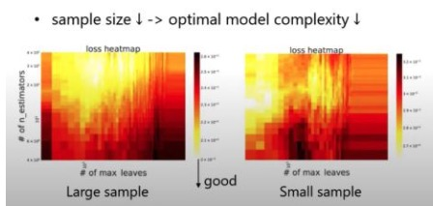

To summarize, the cost k for a fixed combination of learners varies in two ways: the first is proportional to the sample size; the second is proportional to the hyperparameters, such as the number of trees in a tree model.

An additional feature is the automatic optimization of the model learning process itself. The ability to learn to recognize a new object from a few photographs, for example, increases with age and experience, as does the ability to learn to master new knowledge. The ability of machine learning algorithms to have a similar automated "experience growth" capability, without relying on the experience of the user, is also an important goal to achieve in the near future.

FLAML is focused on speed and efficiency, and the key is that it does not perform a mindless global search, but rather selectively chooses Learner, Hyperparameter, sample size, and resampling strategy, as illustrated in the following design architecture. To proceed as shown in the following diagram, the first step will be to select the appropriate resampling strategy, learner, and hyper-parameters in steps 0-2, followed by the third step, in which the controller will select different algorithms from the ML layer and calculate the corresponding validation error as well as the associated cost. FLAML will repeat steps 0-3 as many times as necessary until the time limit is reached.

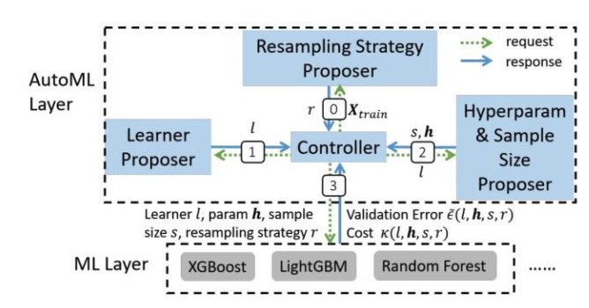

(1)XGBoost

XGBoost is a member of the integrated learning Boosting family and is an improvement over the boosting algorithm based on GBDT, which fits the residuals on the data using the model's negative gradient as an approximation to the residuals; XGBoost also fits the residuals on the data, but it does so using Taylor expansions; additionally, XGBoost improves the model's loss function by including a canonical term for t.

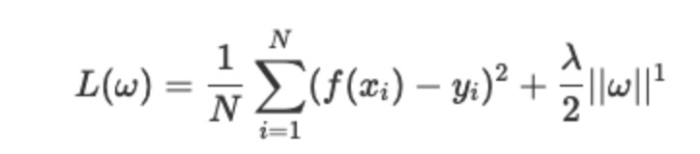

XGBoost's performance is a step above that of GBDT, and its performance can be gauged through various competitions. The most widely held perception of XGBoost is that it automatically utilizes CPU multithreading for parallel computation and also improves algorithm precision. Due to the fact that GBDT frequently requires a certain number of trees to achieve a desired level of accuracy with reasonable parameter settings, the model may require several thousand iterations if the data set is complex. However, XGBoost overcomes this limitation by utilizing parallel CPUs.

While traditional GBDT is based on CART trees, XGBoost also supports linear classifiers, which are equivalent to L1 and L2 regularized logistic regression. While traditional GBDT optimization only uses first-order derivative information, XGBoost performs second-order Taylor expansion on the cost function to obtain both first- and second-order derivatives; XGBoost also adds a regularization term to the cost function to control the model's complexity. In terms of trade-off variance bias, it reduces the variance of the model, simplifying the learned model and preventing overfitting, another feature that distinguishes XGBoost from traditional GBDT.

Shrinkage, proportional to the rate of learning (eta in XGBoost.) After one iteration, XGBoost multiplies the weights of the leaf nodes by this factor, primarily to reduce the influence of each tree and to provide additional learning space later.

Sampling in columns. xGBoost draws inspiration from random forests and supports column sampling, not only to avoid overfitting but also to minimize computation.

Missing value handling. XGBoost can also learn the direction of its split automatically for samples with missing feature values.

Parallelism is supported by the XGBoost tool. Boosting isn't a serial structure. Notably, XGBoost's parallelism is not tree-granular; additionally, XGBoost does not proceed to the next iteration until one iteration has been completed, and the cost function of the tth iteration contains the predicted values from the previous t-1 iterations. XGBoost's parallelism is at the feature level. Sorting the values of the features is one of the most time-consuming steps in decision tree learning. Prior to training, XGBoost pre-sorts the data and saves it as a block structure that is reused in subsequent iterations, significantly reducing computational effort. Parallelism is also enabled by this block structure. When nodes are split, the gain of each feature is calculated and the feature with the highest gain is selected for splitting, allowing the gain of each feature to be calculated in multiple threads.

Disadvantages

1. the level-wise tree construction method treats all leaf nodes in the current layer equally; some leaf nodes have a very small split gain, which has no effect on the result, but still require splitting, increasing the computational cost.

2. the pre-sorting method consumes a lot of space, not just for storing the feature values, but also for storing the sorting index of the features, and consumes a lot of time traversing each split point to calculate the split gain; however, this disadvantage can be overcome by the approximation algorithm.

(2)LightGBM

It is a new boosting framework from Microsoft; the basic principle is the same as XGBoost, but the focus is on optimizing the model's training speed.

Contrast to XGboost

1. XGboost splits the tree level-wise, whereas lightGBM splits the tree leaf-wise.

This means that all nodes at each level are split identically, which means that the gain of some nodes may be negligible and have little effect on the result, but xgboost also splits, adding unnecessary overhead.

Leaf-wise: means that the node with the greatest splitting gain among all current leaf nodes is chosen for splitting; thus, recursively, overfitting is likely to occur, necessitating the use of the maximum depth limit.

2. lightgbm employs a histogram-based decision tree algorithm, which differs from the exact algorithm used in xgboost. The histogram algorithm requires less memory and has a slight advantage in terms of computational costs.

(1) Memory benefit: Obviously, the memory consumption of the histogram algorithm is (#data * #features * 1Bytes), whereas the memory consumption of the exact algorithm of xgboost is (2 * #data * #features * 4Bytes), because xgboost must save both the original FEATURE value and the sequential index of this value, which require 32-bit floating-point numbers to be saved. (2) computational advantages: while the pre-sorting algorithm traverses all samples of feature values to calculate the split gain, the histogram algorithm traverses only the bucket on the line, time (#bin). 3. The histogram indicates the difference in acceleration.

The histogram of a child node can be obtained by subtracting the sibling node's histogram from the parent node's histogram, which speeds up the computation.

4lightgbm allows for direct input of categorical attributes.

When discrete features are split, each value is treated as a bucket, and the splitting gain is calculated as the gain of "whether it belongs to a category." comparable to single-hot coding. 5. Optimization in multiple threads

The lightgbm parallelized:

1. Parallel Feature

Parallelism is a feature that divides data vertically, that is, it splits the attribute and then distributes the split data to each worker, with each worker calculating the best split point for the data it has and then aggregating it to obtain the global best split point. However, lightgbm asserts that this method entails a significant communication cost. The approach taken by lightgbm is that each worker receives all data and then splits it.

2. Parallelism of data

The traditional data parallelism method is to partition the data set horizontally and then distribute it to each worker, who then creates a histogram of the data and aggregates each worker's histogram to create the global histogram. Additionally, lightgbm asserts that this operation entails a significant communication cost. lightgbm's approach is to use the "Reduce Scatter" mechanism, which does not aggregate all histograms but rather the histograms of different worker features, to split, and finally to synchronize.

(3)Random Forest

Random Forest is a more sophisticated version of Bagging. Random Forest is a more advanced variant of Bagging that builds Bagging integration using decision trees as base learners and incorporates random feature selection into the decision tree training process.

Thus, RandomForest can be summarized as a four-step process.

1. random sample selection, resampling.

2. a random selection of attribute values for features.

3. decision tree construction.

4. Voting in RandomForest (averaging)

As a result, the ability to avoid overfitting is stronger, as is the ability to reduce variance.

Comparing RandomForest and Bagging reveals that RandomForest performs poorly at the start, even more so when there is only one base learner. RandomForest typically converges to a lower generalization error as the number of learners increases. Random forest's training efficiency will also be higher than Bagging's because Bagging constructs individual decision trees using 'deterministic' decision trees, which consider all features when dividing nodes, whereas random forest constructs individual decision trees using 'random' feature counts, which consider only a subset of features.

The fusion method used was bagging, an integrated learning algorithm based on self-help sampling, in which repetition returned a random subset of the sample for training and then voting or averaging the results. Because different base learners are trained independently, it is a parallel algorithm. Using bagging, learners with the same order of time complexity as the base learners are integrated (n times, n is the number of base learners). Bagging can be used for binary classification, multiple classification, or regression, and each base learner's unused training samples can be used for out-of-bag estimation and evaluation of generalization performance. The primary objective of bagging is to reduce variance by approximately two steps. 1. sampling instruction (sampling samples, sampling features) 2. amalgamation

The benefits and drawbacks of RandomForest Pros.

The RandomForest algorithm is capable of solving both classification and regression problems and performs admirably. Due to the fact that it is integrated learning, the variance and bias are low, and the generalization performance is superior; RandomForest is well-suited for high-dimensional datasets; it can handle thousands of input variables and identify the most important ones, making it an effective dimensionality reduction method. Additionally, the model can output the feature's importance level, which is a very useful feature. It is capable of handling missing data; RandomForest can be used to effectively balance the error in a dataset when there is a classification imbalance; it is highly parallelized and simple to implement in a distributed manner; and, because it is a tree model, it does not require normalization between classes.

Disadvantages.

RandomForest is not as effective at solving regression problems as it is at classifying them, as it does not produce continuous output. RandomForest is unable to make predictions beyond the data in the training set, which can result in overfitting when modeling data with specific noise. For many statistical modelers, RandomForest is a black box - you have little control over the model's internal workings and can only experiment with different parameters and random seeds. Ignoring attribute correlations results in overfitting on noisy classification or regression problems.

Thus, by comparing the advantages and disadvantages of these mentioned models. In this project, the best fit model included in the FLAML model is LGBM model. This picture is shown it.The estimator lgbm's best error is 0.0165, which means the accuracy is higher to 98.35%. It is higher than the original deep learning model provided by the parent paper, which is lower than the Bidirectional LSTM Model Accuracy.

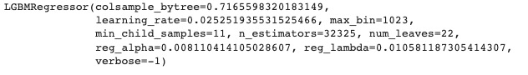

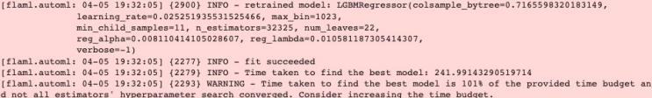

1. Conclusion

|  |  |
| --- | --- |
| Model | Accuracy |
| LSTM Model | 73.73% |
| Bidirectional LSTM Model | 98.44% |
| Random Forest | 40.05% |
| XGBoost | 97.37% |
| LightGBM | 98.35% |

As has been studied, the rising volume of internet fake news poses a threat to society and government. Moreover, the yearly growth in the number of hoaxes and the development of artificial intelligence taught to produce text highlight the need for effective systems to identify between deceptions.

In this paper, it offer three unique architectures for fake news detection text analysis. Two of them are built, optimized, and trained from scratch, while the last one is fine-tuned from FLAML, a pre-trained language model structure that has produced state-of-the-art results in a wide variety of deep learning tasks. Bidirectional LSTM achieved the highest accuracy. LightGBM in FLAML also have the second highest accuracy,which is the best performance in the provided machine learning algorithm. But, the Bidirectional LSTM model performed excellent performance on the NLP task area, it is cannot say that it could be useful in other area. The FLAML is different. It could choose the Learner, Hyperparameter, sample size and resampling strategy automatically, which means it could have more potential solution in other area. Thus, the selection of models is depend on the different situation.



Figure: Confusion matrix over the test dataset

This training ran for two epochs with the hyperparameters specified. Afterward, the model was assessed over the test fold attaining an accuracy of 0.98 and an F1 measure of 0.97. In addition, this graphic depicts the confusion matrix obtained.

Although there is no benchmark that can be used to evaluate fake news detection tasks, the model presented here outperforms the results in the original work, which compiled the dataset used [9] (with an accuracy of 73.73 percent ) and obtained better metrics other relevant compared to all models (see Section IV). This allows us to suppose that neural networks focused on identifying fake news can be trained using only textual characteristics and that state-of-the-art outcomes can be attained using the suggested technique.

The experience gathered during the creation of these models allows us to illustrate that the employment of deep learning models for this purpose may be helpful for a wide variety of stakeholders, from social networking corporations to end consumers, to offset the rising deceit of the Internet.

Regarding future developments of these models, first of all, additional data must be obtained, especially from the most recent time. This was also proposed by the researchers that collected the TI-CNN dataset, as much of the news there was gathered during the US campaign. In order to achieve the objectives, a system that automatically collects quality news should be designed. Finally, in order to make these models available to people, there is a requirement for certain means of serving users, e.g., apps on social networking platforms, encapsulation into browser extension packages, mobile application integration. etc. Considering these efforts, I expect that this technology will be ready for successful usage in the actual world.

##### References

1. Shu, K., Sliva, A., Wang, S., Tang, J., Liu, H.: Fake news detection on social media: A data mining perspective. ACM SIGKDD explorations newsletter 19(1), 22–36 (2017)
2. Fake news in india - wikipedia. https://en.wikipedia.org/wiki/Fake news in India, (Accessed on 12/25/2020).
3. Wani, A., Joshi, I., Khandve, S., Wagh, V., & Joshi, R. (2021). Evaluating deep learning approaches for covid19 fake news detection. *Combating Online Hostile Posts in Regional Languages during Emergency Situation*, 153–163. https://doi.org/10.1007/978-3-030-73696-5_15.
4. Bhattarai, B., Granmo, O.-C., & Jiao, L. (2021, May 19). Explainable tsetlin machine framework for fake news detection with credibility score assessment. arXiv.org. Retrieved March 16, 2022, from https://arxiv.org/abs/2105.09114.
5. Saikh, T., De, A., Ekbal, A., & Bhattacharyya, P. (2020, May 11). *A deep learning approach for automatic detection of fake news*. arXiv.org. Retrieved March 16, 2022, from https://arxiv.org/abs/2005.04938.
6. Rodríguez, Á. I., & Iglesias, L. L. (2019, October 11). *Fake news detection using Deep Learning*. arXiv.org. Retrieved March 16, 2022, from https://arxiv.org/abs/1910.03496v2.
7. Patwa, P., Bhardwaj, M., Guptha, V., Kumari, G., Sharma, S., PYKL, S., Das, A., Ekbal, A., Akhtar, S., Chakraborty, T.: Overview of constraint 2021 shared tasks: Detecting english covid-19 fake news and hindi hostile posts. In: Proceedings of the First Workshop on Combating Online Hostile Posts in Regional Languages during Emergency Situation (CONSTRAINT). Springer (2021).
8. Wang, W.Y.: ” liar, liar pants on fire”: A new benchmark dataset for fake news detection. arXiv preprint arXiv:1705.00648 (2017)
9. Yang Yang, Lei Zheng, Jiawei Zhang, Qingcai Cui, Zhoujun Li, and Philip S. Yu. Ti-cnn: Convolutional neural networks for fake news detection, (2018).